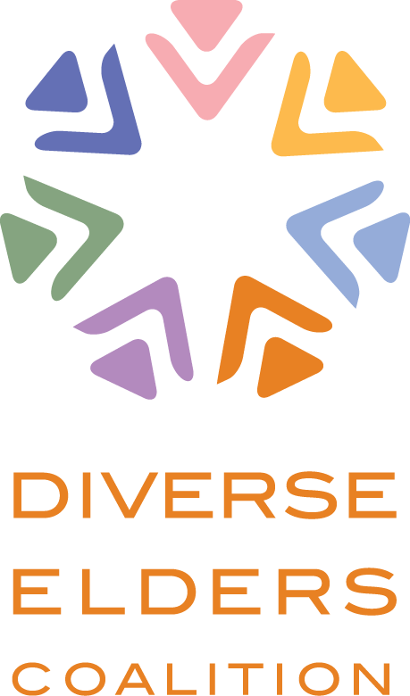

May 29, 2015

Nora Super
Executive Director
White House Conference on Aging
200 Independence Avenue SW, Suite 637D
Hubert Humphrey Building
Washington, DC 20201

Dear Ms. Super:

The Diverse Elders Coalition would like to take this opportunity to respond to the four Policy Briefs released by the 2015 White House Conference on Aging (WHCOA). The WHCOA is a once-in-a-decade opportunity to not only focus the nation’s attention on the needs of our elders but to also reflect on and respond to the changes in our communities and in our nation since the last conference.

The United States has changed dramatically since the last WHCOA convened in 2005. Demographically, the nation is not only moving to what has been referred to as the “Graying of America” as Baby Boomers hit retirement age, but also the “Browning of America” with an increasingly multi-racial, multi-ethnic population. Discussions around racial justice and its impact on our seniors are increasingly important to have, not just at the dinner table, but at the policymaking table. These changes have come hand-in-hand with the emergence of the LGBT community as a constituency whose needs in the policy arena are transforming conversations around gender, marriage, and the very nature of who is considered an “underrepresented minority.” Finally, the challenges faced by both indigenous communities and immigrants with varying degrees of citizenship status have brought forward more fundamental questions about who even gets to be considered “an American.”

These new circumstances and new realities, both political and demographic, require new kinds of policy discussions, and we commend the WHCOA team for attempting to grapple with them as you prepare for this important conference. We appreciate that the WHCOA website talks about “broad public engagement” and “accessibility to the widest possible audience;” we also applaud your commitments to our diverse constituencies through meetings, events, and correspondence. Through specific events intentionally targeting diverse constituencies, such as the May 6th listening session with tribal elders and the May 7th Los Angeles Town Hall, you have demonstrated commitment to proactively incorporate our communities’ voices into your work.

305 Seventh Avenue
15th Floor
New York, NY 10001

T 212-741-2247
F 212-366-1947

diverseelders.org facebook.com/diverseelders
twitter.com/diverseelders

MEMBER ORGANIZATIONS

National Asian Paciﬁc Center on Aging
National Hispanic
Council on Aging
National Indian
Council on Aging
Services and Advocacy
for GLBT Elders
Southeast Asia Resource Action Center

We recognize and appreciate your commitment, but we need more support. And our communities need more support. The elders our member organizations serve continue to be among the most marginalized. Ageism, racism, xenophobia, homophobia, and transphobia create additional layers to the considerable challenges our communities face as they age. These challenges require our full commitment and creative partnership to engage our communities and make sure they’re part of your important work to find policy solutions.

We have identified three major themes that we would like to address in response to the WHCOA policy briefs on Healthy Aging, Elder Justice, Retirement Security, and Long Term Services and Supports, which include:
- Data/Research;
- Cultural and Linguistic Competence; and
- Non-Discrimination and Equal Treatment Under Law

These themes represent opportunities for the WHCOA to address specific issues in your outreach, policy analysis, and conference planning, and we look forward to serving as thought partners and resources to you in that important work.

Below, we provide some initial observations about each theme and recommendations for future work. Specific recommendations appear in bold.

Data/Research
The historical marginalization and intentional erasure of our constituencies’ lives and experiences, coupled by pragmatic realities of small sample size and data collection challenges, has resulted in a “cycle of mutual neglect,” where policymakers do not (or will not) identify the needs of our communities, and our communities get the message (intended or not) that their needs do not matter. In turn, our communities, thinking their needs do not matter, do not (or will not) engage policymakers, and policymakers take silence to mean consent with the status quo. Even when there is data about our communities, at times, that data is only collected and reported on in the aggregate, masking real and serious disparities specific communities face.

Despite the WHCOA’s best intentions, there remains much work to do in gathering the best knowledge about our communities. For every instance where our member organizations have partnered with our constituencies to engage the WHCOA’s work, there are an equal number of instances where we remain invisible. The Policy Briefs themselves only make uneven references to communities of color and American Indian/Alaska Natives. On LGBT elders and their needs, the Policy Briefs are resoundingly silent.

Our member groups recognize the challenges of data collection and data disaggregation for our communities. On many occasions, the lessons our groups have learned in strategic over-sampling and community-based research methodology represent the best available current thinking about how to understand our communities’ needs. The WHCOA represents an important opportunity to bring together that best thinking and be a central repository for the best research about diverse elders, and we call on you to gather best practices in terms of data collection and disaggregation and to employ them in the research you do to inform the policies that are put forward.

Cultural and Linguistic Competence
Many of the recommendations put forth in the Policy Briefs talk about inclusion and intend to be applicable to all elders, but we know that one solution does not fit all. It is often our constituencies whose needs are least addressed in such cookie-cutter approaches; thus, our member organizations have spent decades promoting more culturally competent responses to addressing our elders’ needs. Making sure that elders who are English language learners (ELL) have services that are in the languages they speak is just one way to move towards cultural and linguistic competence. Recognizing that “culture” is not only defined through traditional lenses of race, ethnicity, or nationality, but also by other ways that people identify such as gender, gender identity, or sexual orientation, is a key component to building culturally competent services and programs. Again, our member organizations have built track records of success in articulating and implementing such practices and their example would be of great help to your work. We strongly urge the WHCOA to identify the best practices in terms of providing culturally and linguistically appropriate services and programming to ALL elders and to commit to implementing them across the board.

Non-Discrimination and Equal Treatment Under the Law
Despite advances that our communities have achieved on the road to equality, there remain considerable barriers to their full participation in every facet of public life. It is often difficult enough to move through the world as a person of color, or an LGBT person; the additional barriers that age places on the individual complicates the picture even further. The Policy Briefs and the analyses they put forth do not sufficiently recognize this complexity and remain silent on the unique needs of elders who face multiple forms of discrimination. The safety net of federal programs and benefits that are intended to support everyone in their old age are unevenly distributed on the basis of citizenship; they are often unavailable not only for non-citizens and undocumented immigrants, but also for American Indians/Alaska Natives and other indigenous communities with varying degrees of citizenship. LGBT elders, despite the rapid pace of progress being made on issues like marriage equality, still are not afforded federal protections against discrimination. Communities of color continue to experience de facto, if not de jure discrimination and have unequal outcomes as a result. The policies that are intended to benefit all elders must be as inclusive as possible and contain the strongest language available around non-discrimination and equal treatment.

These overarching themes offer a framework for the WHCOA to improve its work to address the needs of ALL elders. The Diverse Elders Coalition and its member organizations stand ready to partner with you to meet those needs and to fully realize the conference’s goal to “ensure that Americans throughout the lifespan have the opportunity to learn and develop skills, engage in productive work, make choices about their daily lives, and participate fully in community life.”

If you require further information, please do not hesitate to contact me on behalf of the coalition by e-mail at bdeguzman@diverseelders.org or by phone at 202-347-9733. Thank you for your support and we look forward to your continued partnership.

Sincerely,

Ben de Guzman

cc: Michael Adams, SAGE
Randella Bluehouse, NICOA
Dr. Yanira Cruz, NHCOA
Quyen Dinh, SEARAC
Dr. Wesley Lum, NAPCA

